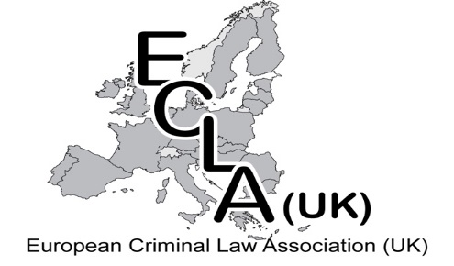
ECLA UK
Membership Application Form

Title (eg Dr/Mr/Ms) | First Name(s)
Home Telephone
Email Address

SECTION TWO – Declarations And Confirmation
I apply to become a member of the European Criminal Law Association (UK).
Your personal details will be held in accordance with the EU General Data Protection Regulation 2018, detailed in our Privacy Policy available on our website. www.eucriminallaw.com
Tick here
 | I confirm that the information I have provided is accurate.
 | I confirm that I have read and accepted ECXLA UK’s Constitution. The Constitution is available on www.eucriminallaw.com
 | I confirm that I have understood and accepted ECLA UK’s Privacy Policy. The Privacy Policy is available on www.eucriminallaw.com
Full Name |  | Signature | Date
Membership Fee is £20 or £10 for students, payable to ECLA UK by cash or cheque to Hon Treasurer or direct to our bank.
by post to:
Treasurer
The UK European Criminal Law Association
Collins Cottage
Kingston Lisle
Oxfordshire
OX12 9QK
by Bank Transfer to ECLA UK at:
HSBC / Sort Code: 40-12-03 / Account No: 81288776.
If making payment by bank transfer please reference this with your name.

